Installation of Squid

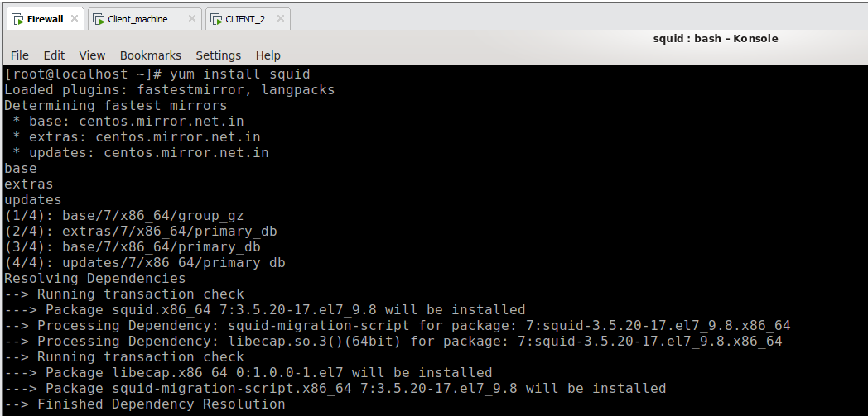

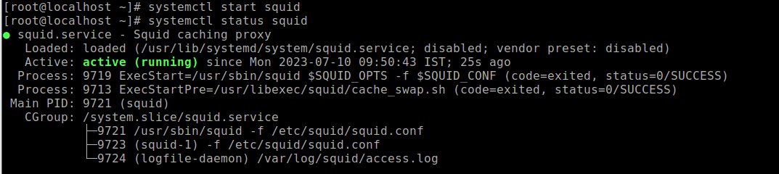

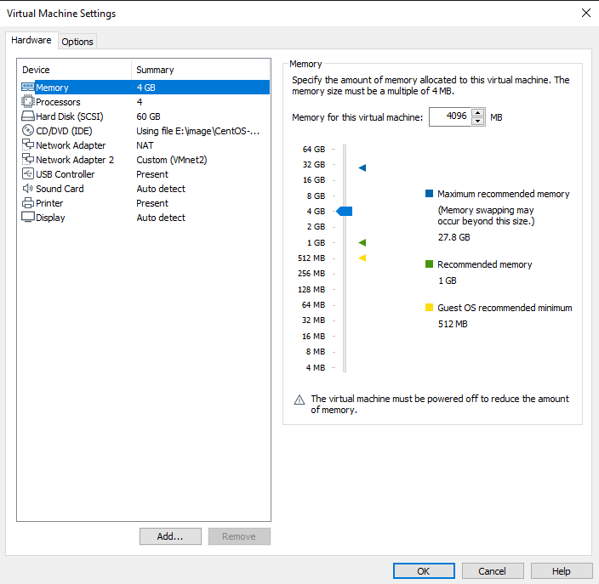

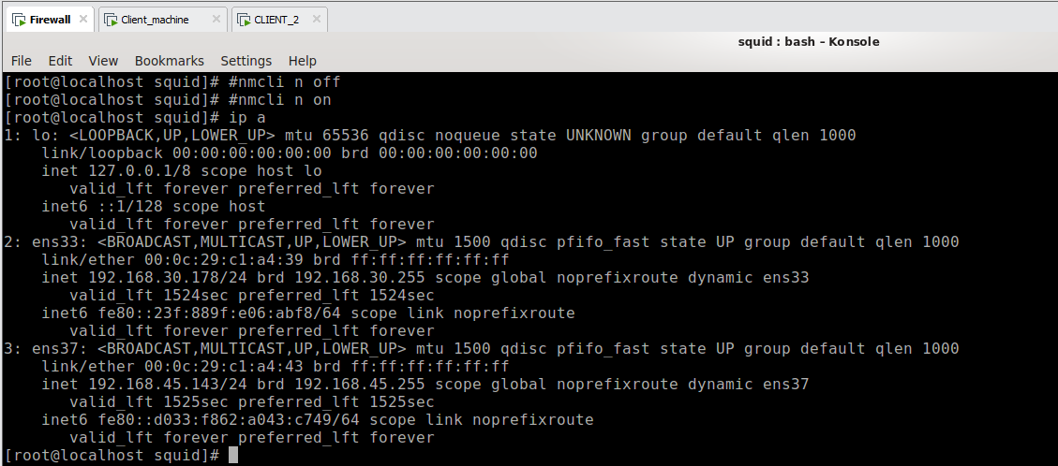

Now go to the client(Centos) machine and go to the firefox browser and search proxy setting and click on manual proxy configuration and enter the ip address of the firewall machine host ip and then click on ok

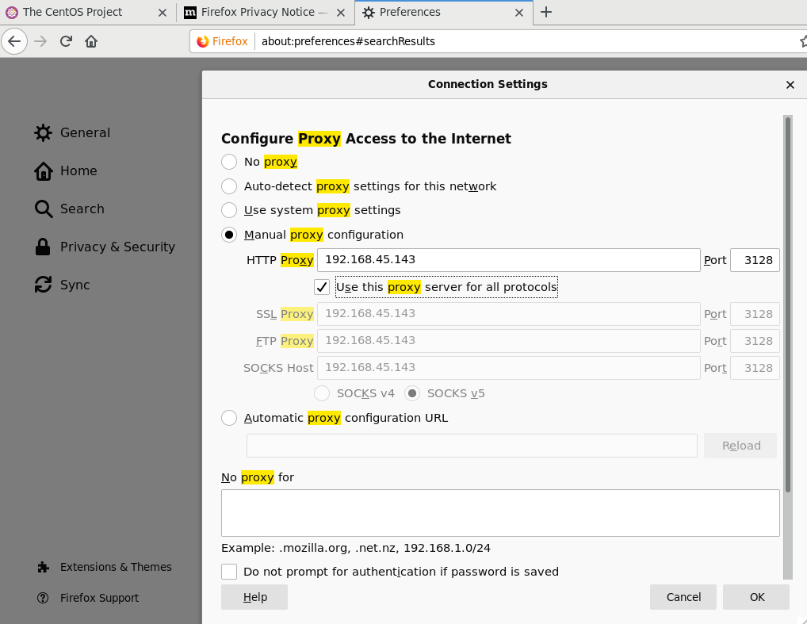

Then run the nmtui command and give the manual ip address for the machine.

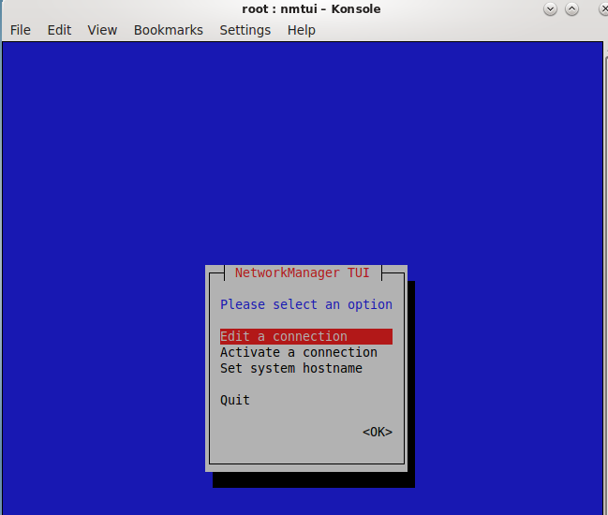

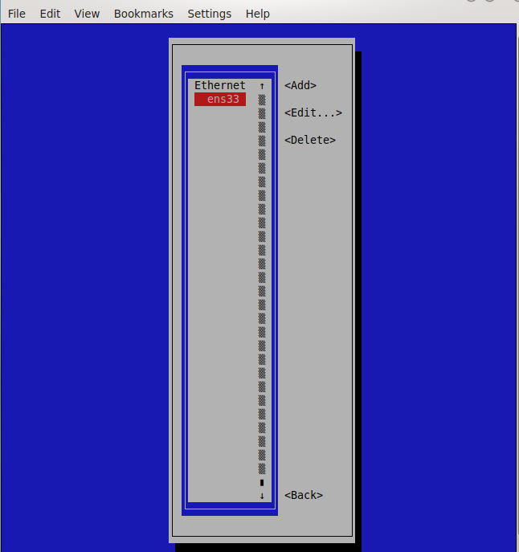

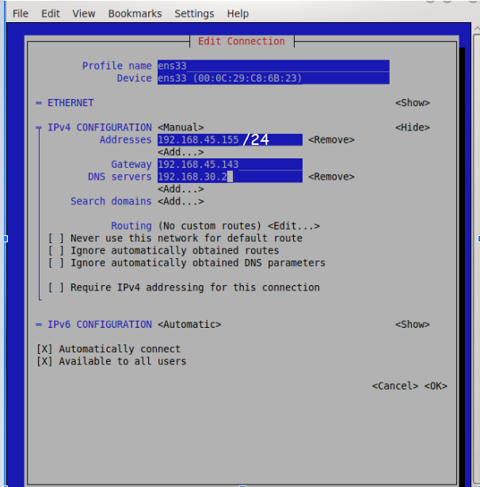

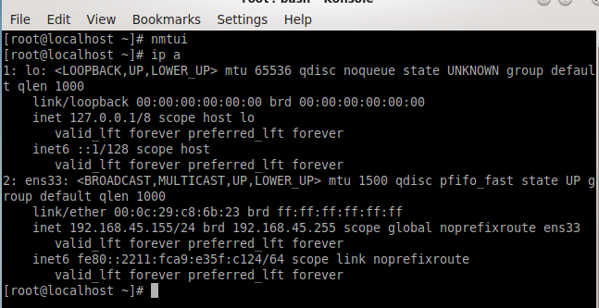

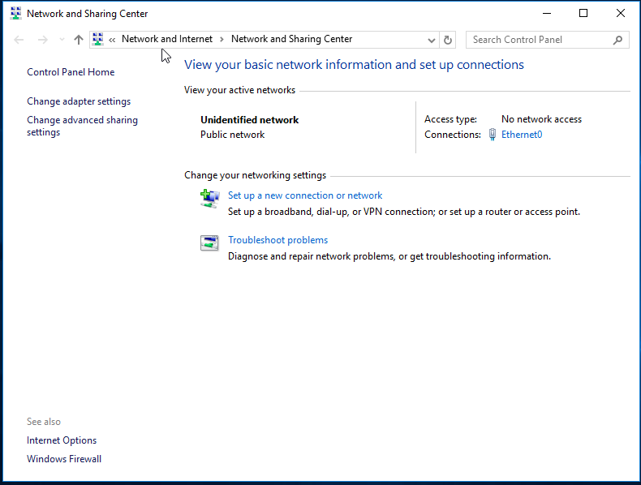

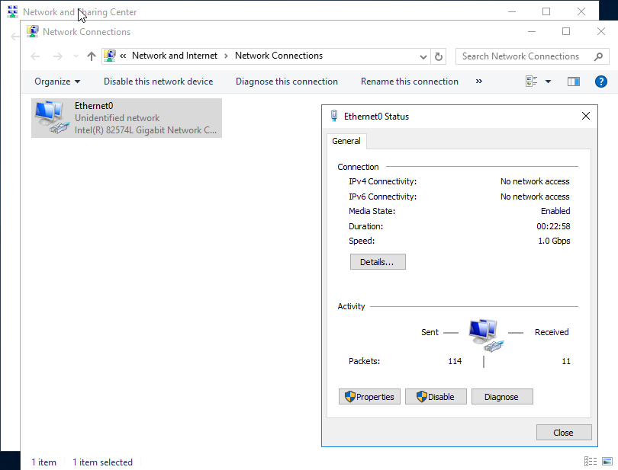

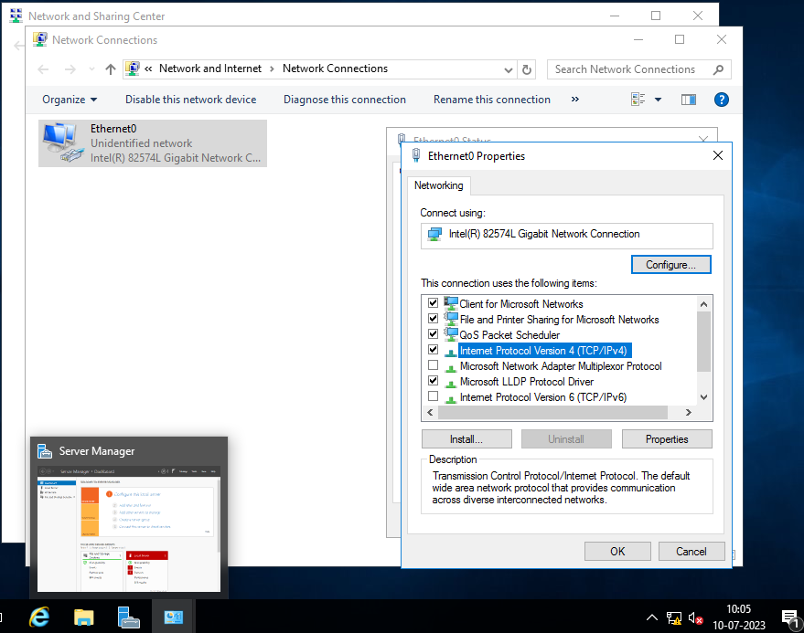

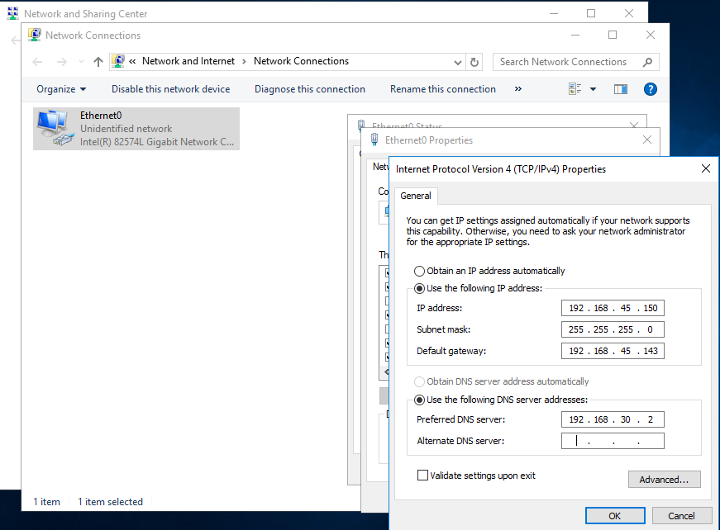

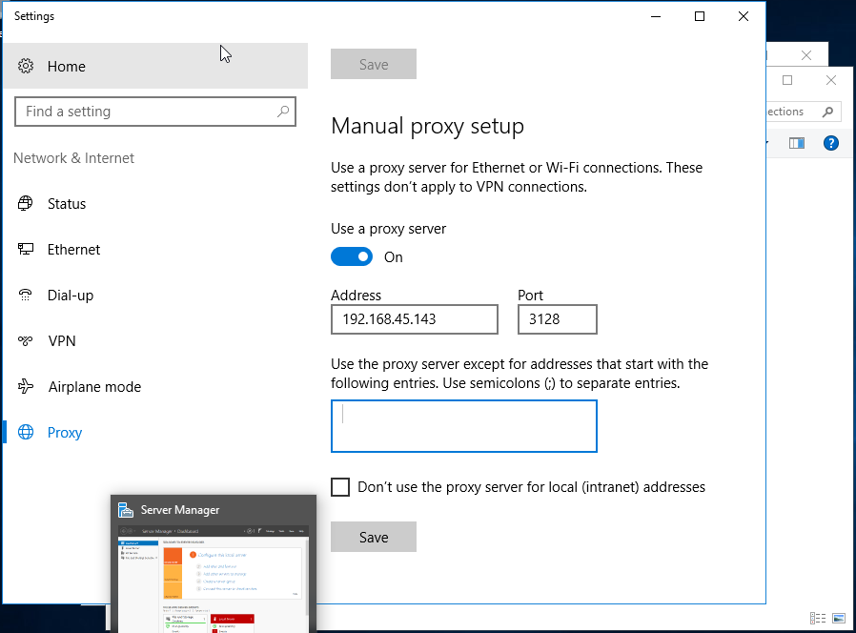

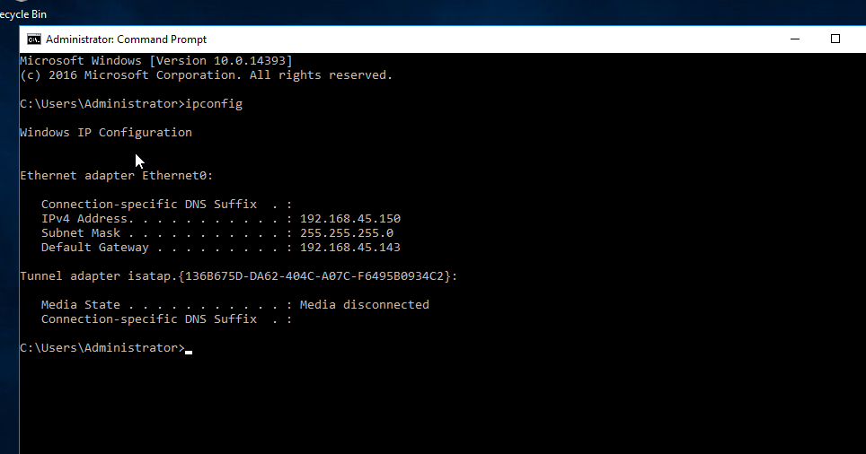

Now go to the Firewall/Squid-server go to the cd /etc/squid

Then open the squid.conf file and edit the following rules

Uncomment the http_access allow localnet and cache_dir ufs /var/spool/squid 2048 16 256

Then visible_hostname proxy.hpcsa.lab – add this line below the cache_dir line

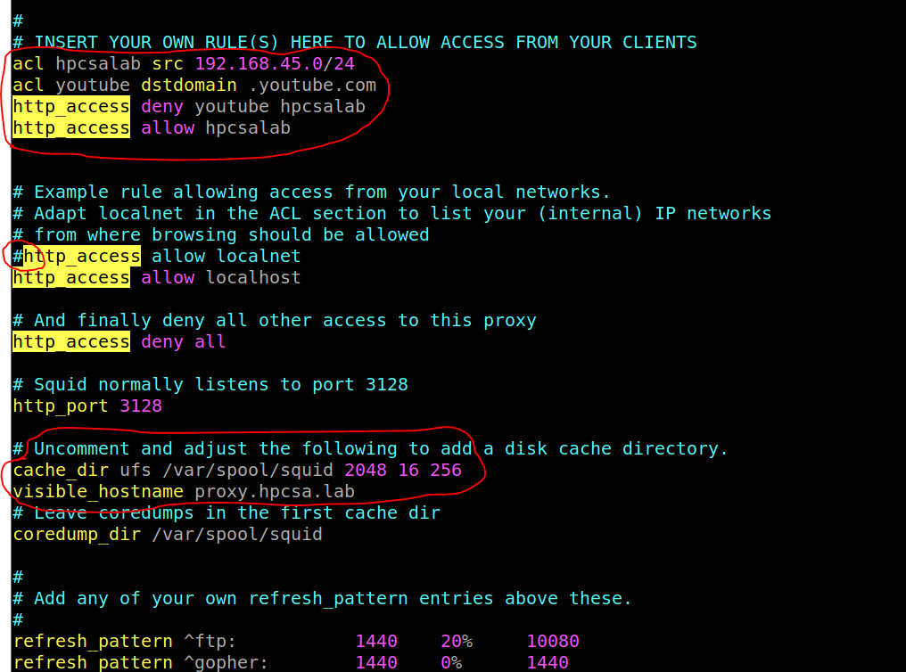

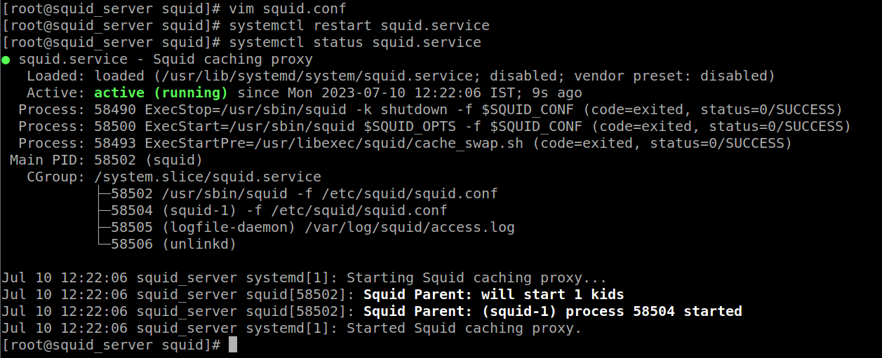

Now go to the Client machine and type [www.youtube.com](http://www.youtube.com) on web url we will not able to access the youtube because we deny the youtube in squid.conf file in firewall

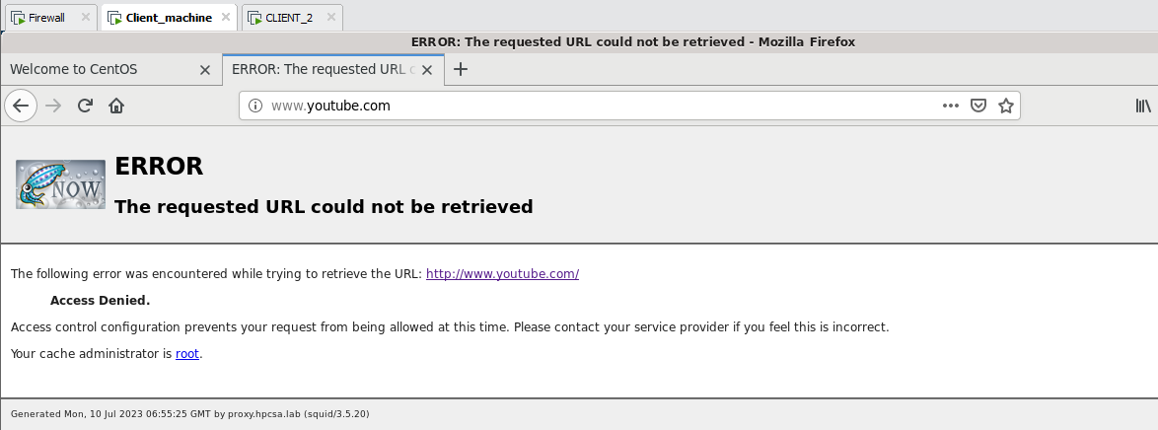

Now create one file in /etc/squid directory i.e blocked.txt and enter the website whatever we want to block or deny it i.e .facebook.com , .redhat.com , wikipedia.com

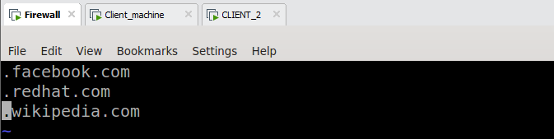

Now insert the rule in the squid.conf file as per the following.

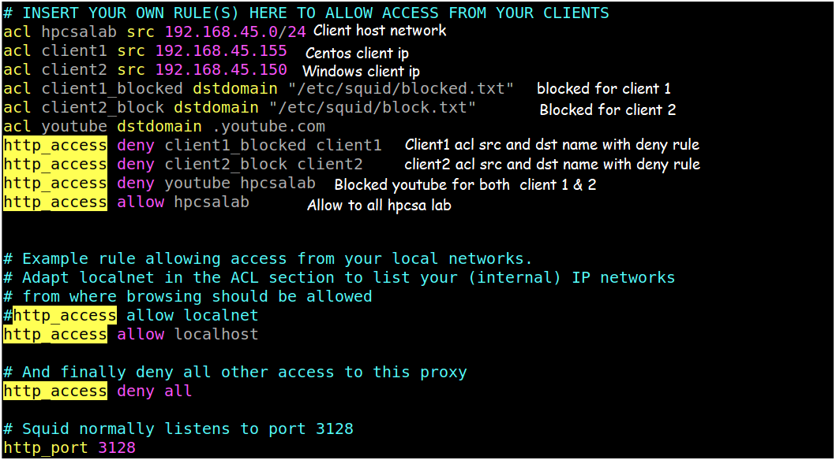

Enter the youtube.com on client 2 web browser then it doesnt work

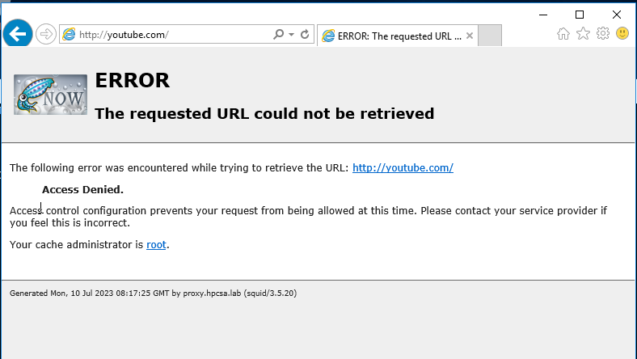

When we accessing the other websites rather than the blocked websites then we will be able to access that websites.

